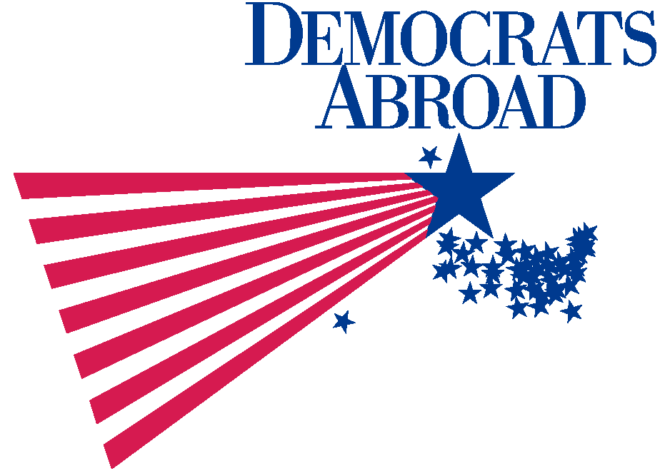

PRESS RELEASE

Democrats Abroad International has celebrated its 40th anniversary with the most successful caucus yet.

The worldwide branch of the Democratic National Committee (the ruling body of the U.S. Democratic Party) held its regional caucuses and global convention in Edinburgh the weekend of March 26-28.

This was the largest worldwide meeting held by Democrats Abroad. Two hundred Americans living in 21 countries around the world came to Scotland to support the party.

Delegates were selected to carry Democrats Abroad’s votes to the party’s national convention in Boston, which will be held during the week of July 25th. The DNC has granted the organization the status of the 51st state for administrative purposes and gives them nine votes at the convention. Votes can be divided in to fractions to give a broader representation in the delegation.

Delegates to the 2004 Democratic National Convention
Rachelle Valladares United Kingdom Int’l Chair
John McCreery Japan Int’l Vice Chair
Rhoda Green Canada
Joseph Smallhoover France
Peter Alegi Italy
Robert Bell Canada
Lois Grjebine France
Ruth McCreery Japan
Ronald Schlundt Germany
Christine Schon Marques Switzerland
Joseph Green Canada
Lauren McLeran Deane Japan
Dorothy Dillard Switzerland
Andrew Dier Columbia
Caittin Kraft-Buchman Switzerland
Michael Lange United Kingdom
Carol D. Mardell Mexico
Scott Peters Germany
Teresa ‘Terry’ MacMillan Japan
Christopher Joshi Hansen United Kingdom
Martina Guzman Germany
J. Brad DeLange Sweden
Meredith Gowen LeGoff France
Josh Kravitz Executive Director – Washington D.C.
Michael Ceurvorst Hong Kong
Robert Checkoway The Netherlands
Katherine Chassing France

Newly Elected DNC Members
Connie Borde France
Jamey Dumas United Kingdom
Liv Gibbons Ireland
Theresa Morelli Italy
Brent O’Leary Japan

Democrats Abroad is active in 60 countries (32 full status countries and 28 committees ‘in formation’). It helps all Americans in a non-partisan effort to register people to vote as well as maintaining contact with the stateside branch of the party.

For further information please contact: Sharon Manitta, International Press Officer
Mobile - +44 (0)7816 271 733, e-mail - pressofficer@democratsabroad.org.

